**Low Fidelity Pages:**

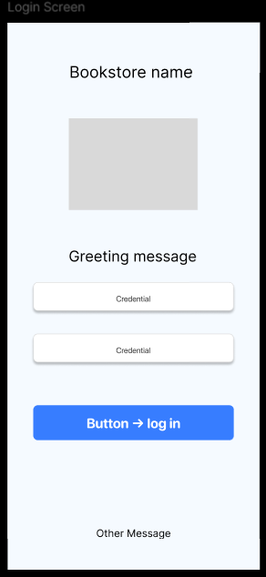

**Login Screen (Low-Fidelity)**

* Wireframe showing basic layout for user login.
* Contains input fields for Email/Password and a login button.
* Focus is on structure, not colors or styling

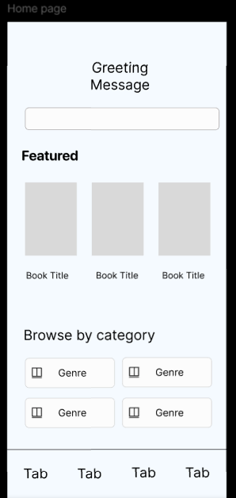

**Home Screen (Low-Fidelity)**

* Simple boxes representing header, search bar, and book sections.
* Placeholder cards for featured books and navigation bar at the bottom.

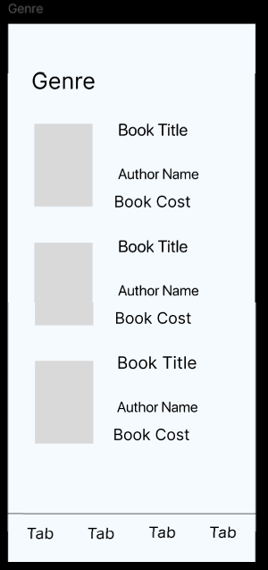

**Book Details Screen (Low-Fidelity)**

* Layout to show book cover, title, description, and “Add to Cart” button.
* Wireframe indicates placement without design styling.

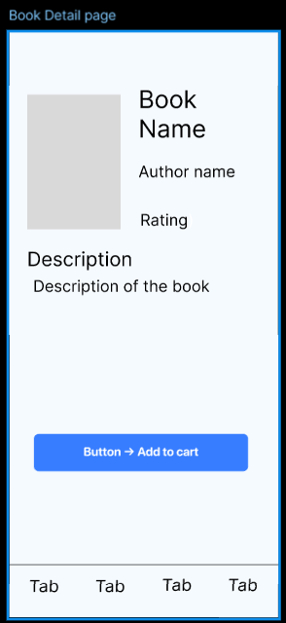

* **Cart Screen (Low-Fidelity)**
* Boxed structure showing list of items, quantity, and checkout button.
* Used to test user flow before adding design.

**High Fidelity Pages:**

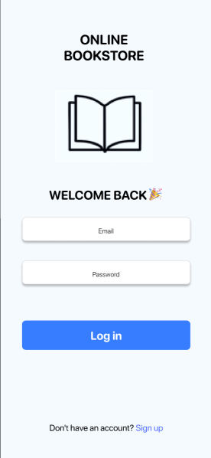

**Login Screen (High-Fidelity)**

* Designed with background color #D1E6FA.
* Input fields styled with soft borders, primary button in blue (#377DFF).
* Clean typography with SF Pro for Apple-like look.

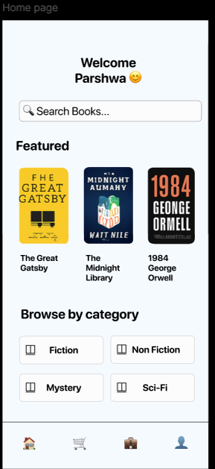

**Home Screen (High-Fidelity)**

* Top bar greeting the user, search bar for books.
* Featured books displayed in a horizontal scrollable carousel.
* Categories grid for browsing genres.
* Bottom navigation bar with Home, Browse, Cart, Profile icons.

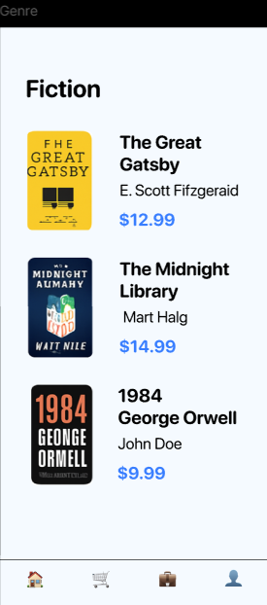

**High-Fidelity**

* Categories displayed in two-column grid with icons and labels.
* Each card styled with rounded corners, white background, and soft shadows.
* Provides an easy way for users to explore book collections.

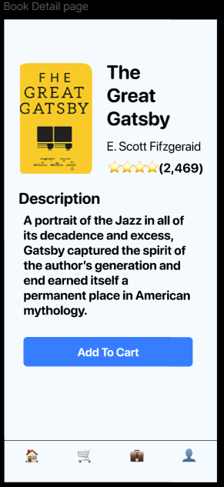

**Book Details Screen (High-Fidelity)**

* Shows selected book cover, title, author, description, and price.
* Prominent “Add to Cart” button styled in primary blue.
* Clear visual hierarchy for readability.

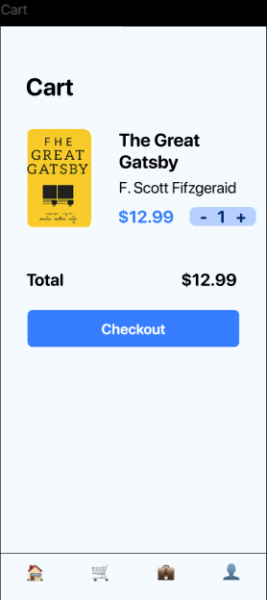

**Cart Screen (High-Fidelity)**

* List of selected items with thumbnails, quantity controls, and price.
* Checkout button emphasized in blue.
* Uses white cards on sky-blue background for clarity.

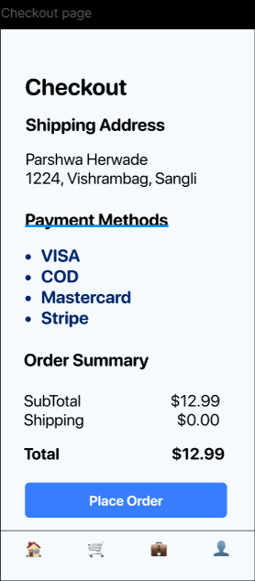

**High-Fidelity**

* Input fields styled with white background and light gray borders (#D9D9D9).
* Clear headings: *Delivery Address*, *Payment Method*.
* Prominent confirm button in blue (#377DFF) for finalizing purchase.
* Consistent typography and spacing for readability.

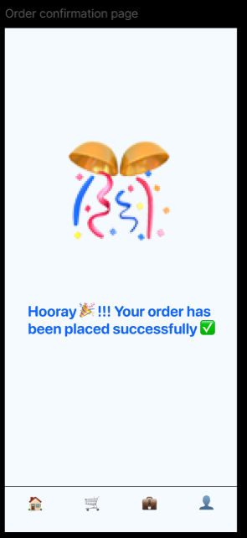

**High-Fidelity**

* Large success icon (checkmark) displayed prominently.
* Text message like *“Your order has been placed successfully!”*.
* A call-to-action button: *“Continue Shopping”*.
* Clean, minimal design to reassure the user

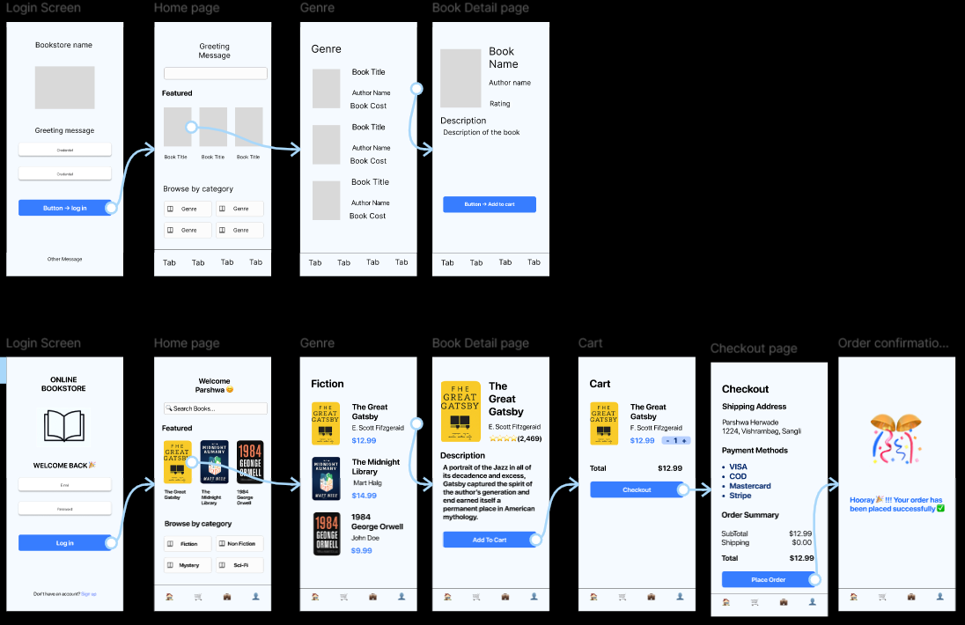

The figure above shows the **complete design process** of the Online Bookstore Mobile Application, including both **low-fidelity wireframes** (top row) and **high-fidelity prototypes** (bottom row) arranged in prototype flow.

* **Low-fidelity wireframes** (top) capture the **basic structure and layout** of each screen. These sketches focus on placement of major components such as login fields, navigation tabs, category grids, book cards, checkout form, and confirmation area. They helped in planning user flow before investing in design details.
* **High-fidelity prototypes** (bottom) present the **final polished design** of the app. Each screen is styled with a sky-blue background (#D1E6FA), white content cards, and a primary blue action color (#377DFF). Icons, typography (SF Pro), and book data have been added to create a realistic user experience.
* The **end-to-end flow** demonstrates the complete journey:
  1. **Login Screen** – user signs in to access the bookstore.
  2. **Home Page** – displays greeting, search bar, featured books, and browsing categories.
  3. **Genre Page** – shows books filtered by category.
  4. **Book Detail Page** – provides book cover, title, description, price, and “Add to Cart” action.
  5. **Cart Page** – lists selected items with cost and checkout option.
  6. **Checkout Page** – captures address, payment method, and order summary.
  7. **Order Confirmation** – success message with visual feedback.

This combined view highlights the **progression from conceptual wireframes to final design** and illustrates how the app supports smooth navigation, consistent styling, and usability principles (Schneiderman’s rules and Norman’s design principles).